Chapter 8
Message-Driven Beans
In this chapter, we will learn about messaging, which is a lightweight vehicle for communications, and is more appropriate than RMI-IIOP in numerous scenarios. We'll also learn about message-driven beans, which are special beans that can be accessed via messaging, and are a new addition to the EJB 2.0 specification.
Specifically, you'll learn about the following concepts:
- An introduction to messaging, including an overview of asynchronous behavior and message-oriented middleware
- A brief tutorial of the Java Message Service (JMS), which message-driven beans depends upon
- The features that message-driven beans have to offer
- How message-driven beans compare with entity and session beans
- How to develop message-driven beans
- Advanced message-driven bean topics, gotchas, and possible solutions
Motivation
In previous chapters, you learned how to code session and entity beans – distributed components that are accessed using RMI-IIOP. RMI-IIOP is a traditional, heavyweight way to call components. While RMI-IIOP may be useful in many scenarios, there are several areas that are challenging for RMI-IIOP. Here are just three examples:
Performance. An RMI-IIOP client must wait (or "block") while the server performs its processing. Only when the server completes its work does the client receive a return result and can continue processing.
Reliability. When an RMI-IIOP client calls the server, it has to be running. If the server crashes, or if the network crashes, the client cannot perform its intended operation.
Support for multiple senders and receivers. With RMI-IIOP, you are limited to a single client talking to a single server at any given time. There's no built-in functionality for multiple clients to broadcast events to multiple servers.
Messaging is an alternative to remote method invocations, and is shown in Figure 8.1. The idea behind messaging is you have "middleman" sitting between the client and the server (a layer of indirection solves every problem in Computer Science). This middleman receives messages from one or more message producers, and broadcasts those messages out to one or more message consumers. Because of this middleman, the producer can send a message and then continue processing. He can optionally be notified of the response later when the consumer finishes. This is called asynchronous programming.
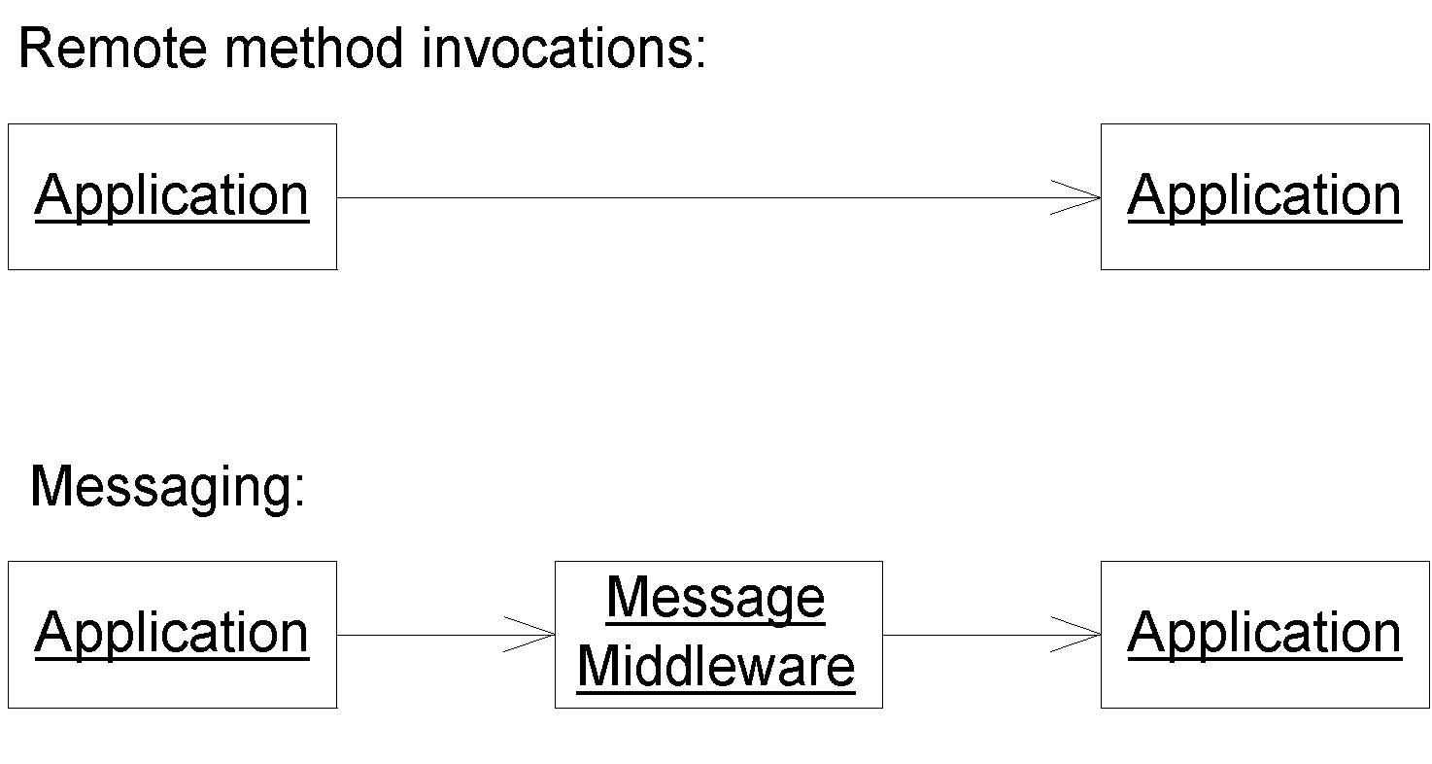
Figure 8.1 Remote method invocations vs. messaging
Messaging addresses the three previous concerns with RMI-IIOP as follows:
Performance. A messaging client does not need to block when performing a request. As a motivational example, when you purchase a book using Amazon.com's 1-click order functionality, you can continue browsing the site without waiting to see if your credit card authorizes. If something goes wrong, Amazon.com sends you a confirmation email afterwards. This type of 'fire and forget' system could easily be coded using messaging. When the user clicks to buy the book, a message is sent which results in credit card processing later. The user can continue to browse.
Reliability. If your message-oriented middleware supports guaranteed delivery then you can send a message and know for sure that it will reach its destination, even if the consumer is not available. You send the message to the MOM middleman, and that middleman routes the message to the consumer when he comes back alive again. With RMI-IIOP, this is not possible because there is no middleman--if the server is down, an exception is thrown.
Support for multiple senders and receivers. Most message-oriented middleware products can accept messages from many senders and broadcast them out to many receivers. This allows you to have n-ary communications.
Note that there are also many disadvantages of messaging. The performance, for one, can be slower in many circumstances due to the overhead of having the messaging middleman. For a complete comparison of when to (and when not to) use messaging, see Chapter 13.
Message-oriented middleware (MOM) is a term used to refer to any infrastructure that supports messaging. There are a variety of products that are considered to have a MOM-based architecture. Examples include Tibco Rendezvous, IBM MQSeries, BEA Tuxedo /Q, Microsoft MSMQ, Talarian SmartSockets, Progress SonicMQ, and Fiorano FioranoMQ. There are a whole host of value-added services that these products can give you, such as guaranteed message delivery, fault tolerance, load balancing of destinations, subscriber throttling of message consumption, inactive subscribers, and much, much more. By allowing the MOM server to address these infrastructure issues, you can focus on the business task at hand.
How does guaranteed message delivery work?
With guaranteed message delivery, the MOM system persists your messages to a file, database, or other store. Your message will reside in the persistent store until it's sent to a message consumer, and the message consumer acknowledges the consumption of the message. If the acknowledgement of a message is not received in a reasonable amount of time, the message remains on the persistent store and is re-delivered.
This feature is beneficial, for example, when the message consumer is brought down on a regular basis for maintenance, and lost messages are unacceptable. This is especially true in industries such as financial services, where messages represent securities changing hands.

A variation on the guaranteed message delivery theme is certified message delivery. Certified message delivery not only ensures the delivery of a message from a producer to a consumer, but will also generate a consumption receipt that will be delivered to the message originator indicating a successful consumption of the message. Certified message delivery is used by producers to better manage communication with consumers.

Another variation of guaranteed message delivery is called store and forward. Store and forward allows a message producer to successfully send a message to a MOM system that is inactive. The producer will transparently spool the message to a local store until the MOM system is reactivated at which point the message will be delivered to the MOM system and forwarded to any available consumers. Guaranteed message delivery without the store and forward option requires producers to send messages to active MOM systems, but consumers do not have to be active. Store and forward with guaranteed message delivery allows messages to be sent whether or not MOM systems or consumers are active or inactive.
The Java Message Service (JMS)
Over the years, MOM systems have evolved in a proprietary way. Each product has its own API, which creates vendor lock-in, because code is not portable to other messaging systems. It also hurts developers, because they need to re-learn each messaging product's proprietary API.
The Java Message Service (JMS) is a messaging standard, designed to eliminate many of the disadvantages that MOM-based products faced over the past years. JMS has two parts to it: an API, which you write code to send and receive messages, and a Service Provider Interface (SPI) where you plug-in JMS drivers. A JMS driver knows how to talk to a specific MOM implementation. The JMS promise is that you can learn the JMS API once, and reuse your messaging code with different plug-and-play MOM implementations (this is a similar idea to the other J2EE APIs, such as JNDI or JDBC).
Let's explore the JMS API, and see how to write a simple JMS program that publishes messages.
Messaging domains
When you perform messaging, you need to choose a domain. A domain is a fancy word for style of messaging. The types of domains are:
Publish/subscribe (pub/sub). Publish/subscribe is analogous to watching television. You have many TV stations broadcasting their signals, and you have many people listening to those broadcasts. Thus, with publish/subscribe, you can have many message producers talking to many message consumers. In this sense, the pub/sub domain is an implementation of a distributed event-driven processing model. Subscribers (listeners) register their interest in a particular event topic. Publishers (event sources) create messages (events) that are distributed to all of the subscribers (listeners). Producers aren't hard-coded to use specific consumers; rather, the MOM system maintains the subscriber list.
Point-to-point (PTP). Point-to-point is analogous to calling a toll-free number and leaving a voice mail. Some person will listen to your voice mail, and then delete it. Thus, with point-to-point, you can have only a single consumer for each message. Multiple consumers can grab messages off the queue, but any given message will be consumed exactly once. In this sense, point-to-point is a degenerate case of publish/subscribe. You can have multiple producers sending messages to the queue, but each message will be delivered only to a single consumer. The way this works is publishers send messages directly to the consumer, or they send messages to a centralized queue. Messages are typically distributed off of the queue in a first-in, first-out (FIFO) order, but this isn’t assured.
The difference between publish/subscribe and point-to-point is shown in Figure 8.2.
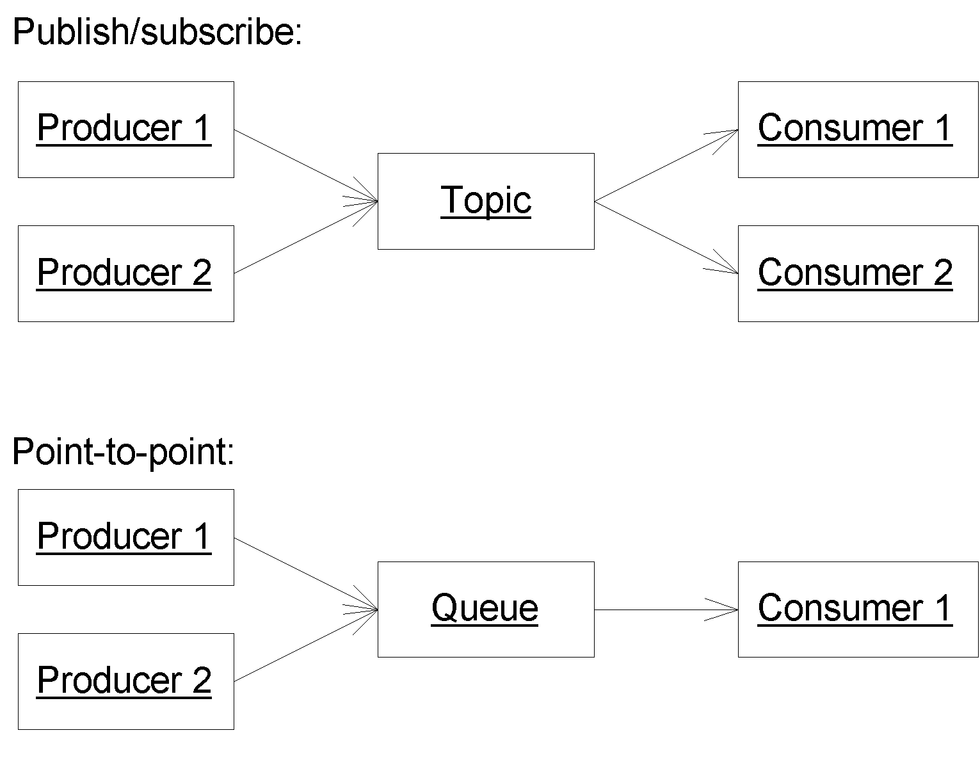
Figure 8.2 Publish/subscribe vs. point-to-point
Note
There is another domain as well, called request/reply, which is less broadly used than the others. The request/reply domain is analogous to RMI-IIOP. It requires any producer that generates a message to receive a reply message from the consumer at some later point in time. Typically, most MOM architectures implement a request/reply paradigm using the technologies supplied in the point-to-point and publish/subscribe domains.
The JMS API
The JMS API is more involved than RMI-IIOP. There are many different interfaces that you need to be familiar with to get going. Despite the complexities involved with working with each of these interfaces, low-level topology issues such as networking protocol, message format and structure, and server location are mostly abstracted from the developer.
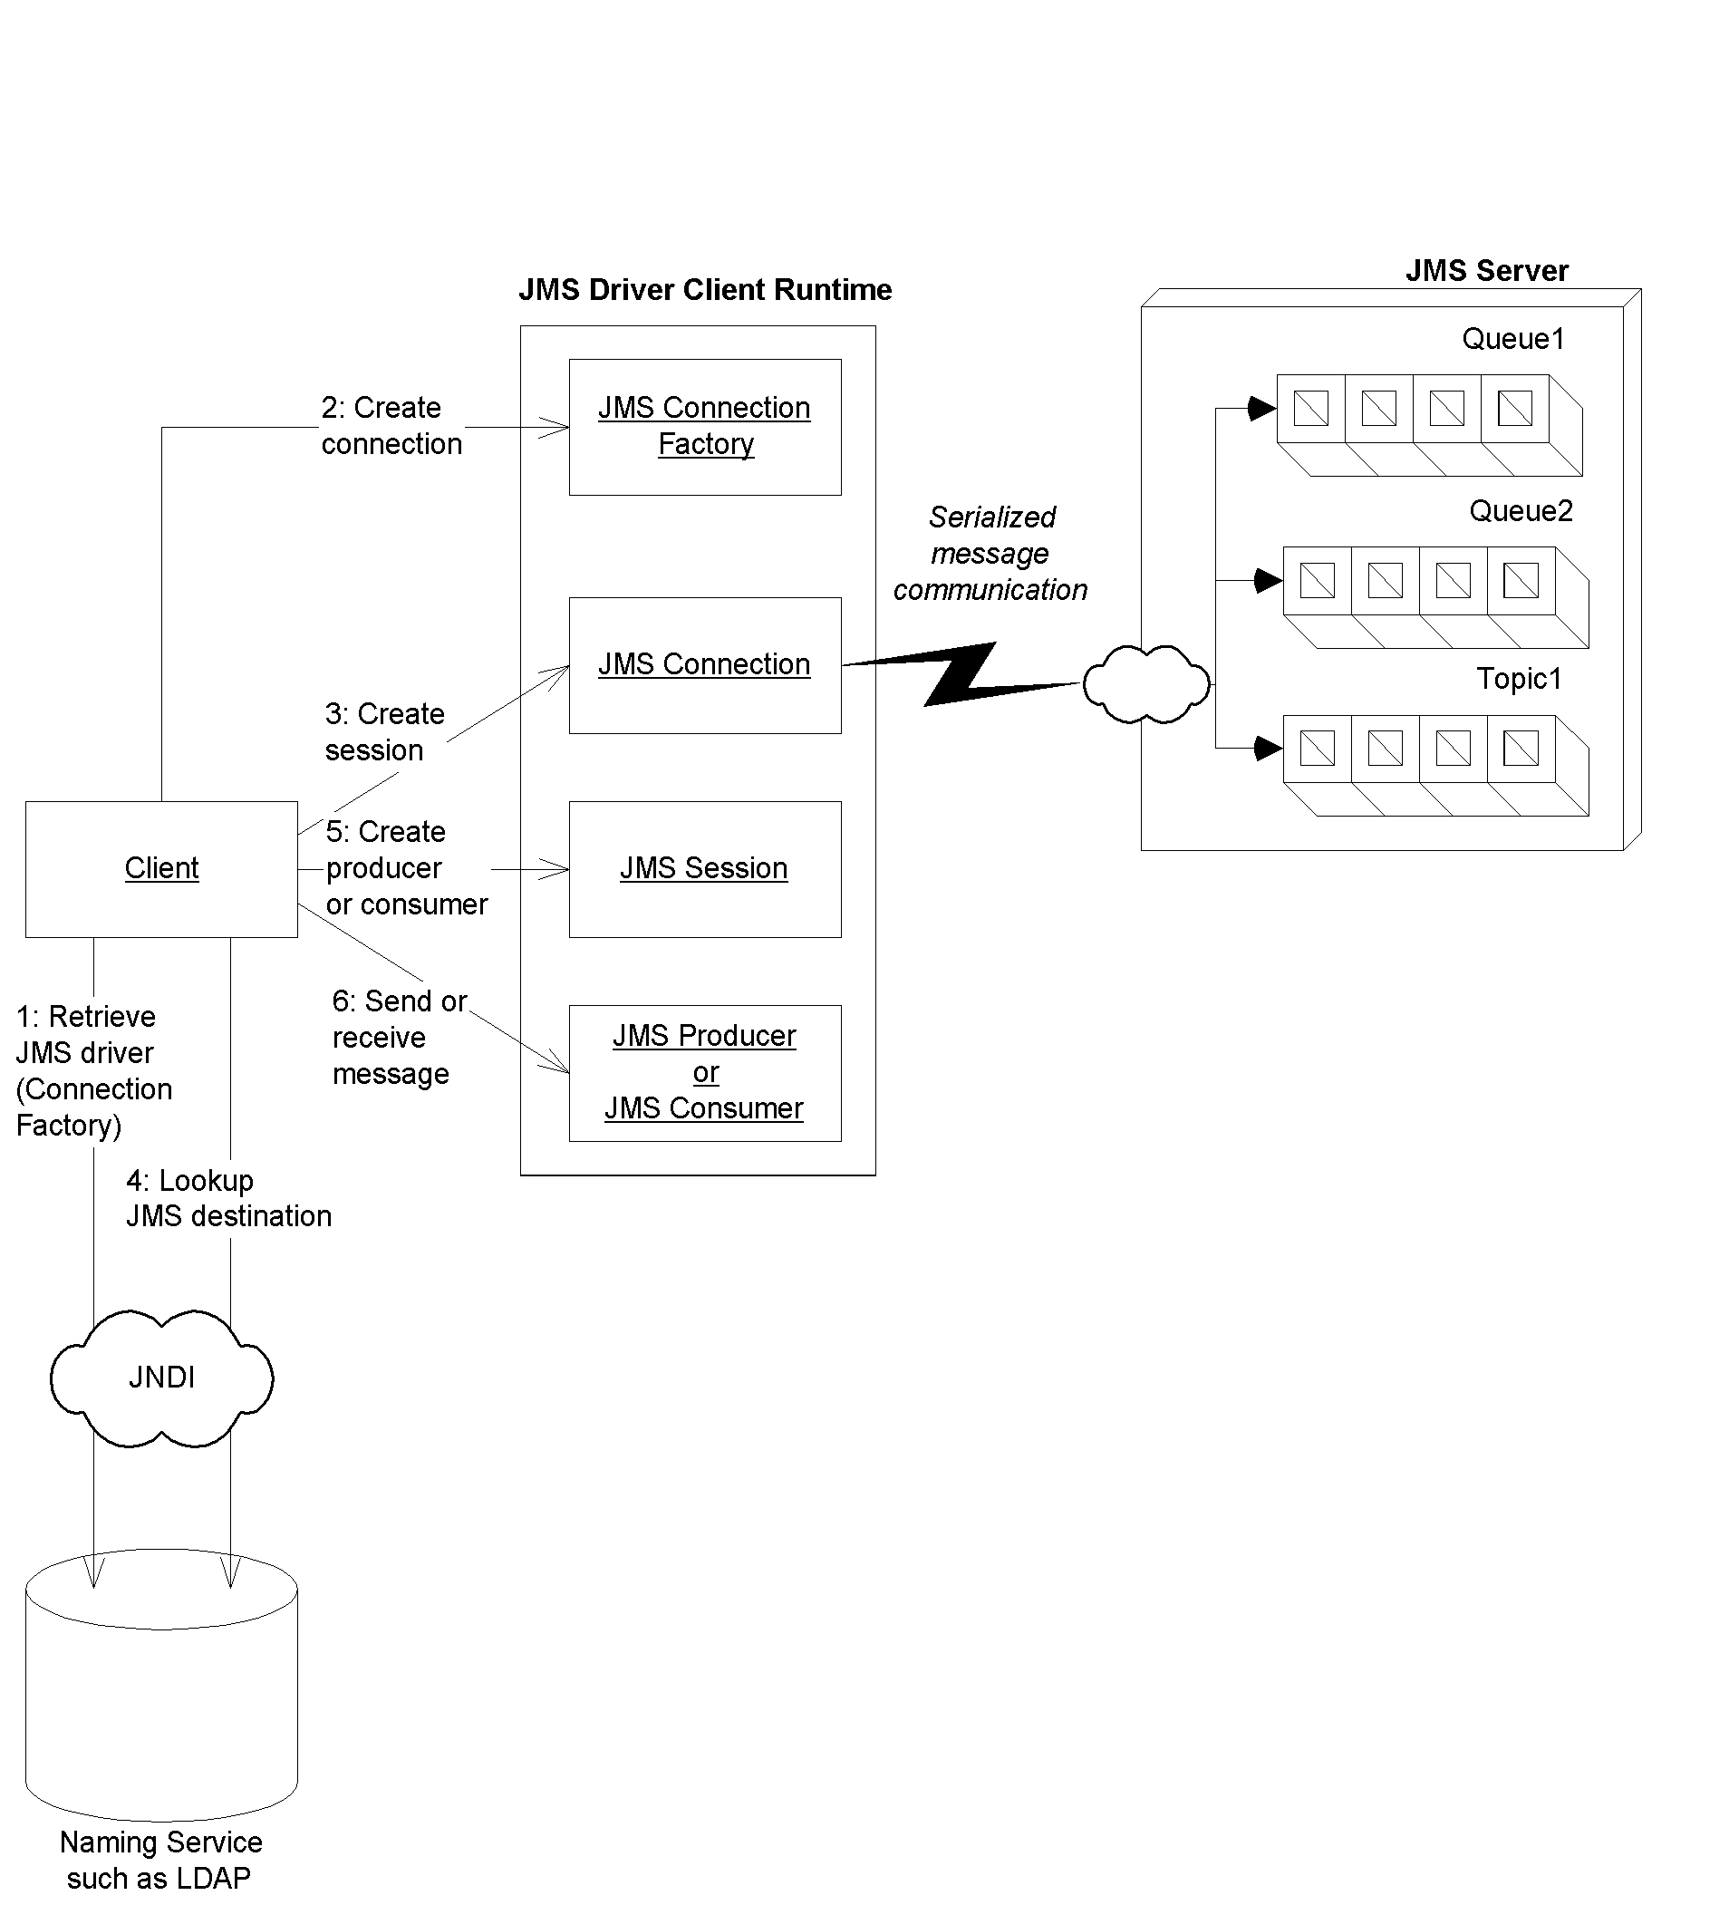
Figure 8.3 Client view of a JMS system.
The JMS programming model is shown in Figure 8.3. It's explained as follows:
- Locate the JMS driver. You first need to get access to the driver to the particular JMS product you're using. You do this by looking up the driver using JNDI, just like with JDBC. The driver is called a ConnectionFactory.
- Create a JMS connection. A JMS Connection is an active connection to the JMS provider, managing the low-level network communications (similar to a JDBC connection). You use the ConnectionFactory to get a Connection. If you're in a large deployment, this connection might be load-balanced across a group of machines.
- Create a JMS session. A JMS Session is a helper object that you use when sending and receiving messages. It serves as a factory for message consumers and producers, and also allows you to encapsulate your messages in transactions. You use the Connection to get a Session.
- Locate the JMS destination. A JMS Destination is the channel to which you're sending or receiving messages. Locating the right destination is analogous to tuning into the right channel when watching television, or answering the right phone, so that you get the messages you desire. Your deployer typically sets up the destination in advance by using your JMS provider's tools, so that the destination is permanently setup. Your code looks up that destination using JNDI. This enables your programs to use the destination over and over again at runtime.
- Create a JMS producer or a JMS consumer. If you want to send messages, you need to call a JMS object to pass it your messages. This object is called the producer. If you want to receive messages, you can call a JMS object and ask it for a message--this object is called the consumer. You use the Session and Destination to make a Producer or a Consumer.
- Send or receive your message. If you're producing, you first need to put your message together. There's lots of different types of messages, such as text, bytes, streams, objects, and maps. After you instantiate your message, you send it using the Producer. If, on the other hand, you're receiving messages, you first receive it using the Consumer, and then you crack it open (depending on the message type) and see what it is.
Everything we just learned applies to both publish/subscribe and point-to-point messaging. The words in italics above represent actual JMS interface names. There are two different flavors of those interfaces, and the flavor you use depends on if you're using publish/subscribe or point-to-point. See Table 8.1 for a list.
Table 8.1 The two flavors of JMS interfaces
Parent Interface | Point-To-Point | Pub/Sub
ConnectionFactory | QueueConnectionFactory | TopicConnectionFactory
Connection | QueueConnection | TopicConnection
Destination | Queue | Topic
Session | QueueSession | TopicSession
MessageProducer | QueueSender | TopicPublisher
MessageConsumer | QueueReceiver, QueueBrowser | TopicSubscriber
Just to get you thinking...@@@COMP: Consistent look for these notes@@@
As you can see from Table 8.1, point-to-point has two types of message consumers: a receiver and a browser. What do you think these are for? And why do you think publish/subscribe only has one type of consumer?
As an example, the code for a client application that publishes a TextMessage to a topic using publish/subscribe is provided in Source 8.1.
import javax.naming.*;

import javax.jms.*;
import java.util.*;

public class Client {

public static void main (String[] args) throws Exception {

// Initialize JNDI
Context ctx = new InitialContext(System.getProperties());

// 1: Lookup ConnectionFactory via JNDI
TopicConnectionFactory factory =
(TopicConnectionFactory)
ctx.lookup("javax.jms.TopicConnectionFactory");

// 2: Use ConnectionFactory to create JMS connection
TopicConnection connection =
factory.createTopicConnection();

// 3: Use Connection to create session
TopicSession session = connection.createTopicSession(
false, Session.AUTO_ACKNOWLEDGE);

// 4: Lookup Desintation (topic) via JNDI
Topic topic = (Topic) ctx.lookup("testtopic");

// 5: Create a Message Producer
TopicPublisher publisher = session.createPublisher(topic);

// 6: Create a text message, and publish it
TextMessage msg = session.createTextMessage();
msg.setText("This is a test message.");
publisher.publish(msg);
}
}
Source 8.1 TopicClient.java.
Most of Source 8.1 is self-explanatory. Here are the answers to a few questions you might have:
- The parameters to InitialContext should be your JNDI driver information. If your JMS provider is integrated into your EJB server, then the JNDI parameters should be the same as those when you lookup an EJB home. You specify this via the command-line using the -D switch to the java runtime. See the book's accompanying source code for example scripts.
- Our JNDI name for the TopicConnectionFactory is "javax.jms.TopicConnectionFactory" but it could be anything--it depends on your container's policy and also where you choose to place it using your container's tools.
- When we create a Session, we pass 2 parameters: false which indicates that we don't want to use transactions (see Chapter 10 for more on transactions), and Session.AUTO_ACKNOWLEDGE that indicates how we should acknowledge messages that we receive. Since our code is sending (not receiving) messages, this parameter doesn't matter. If you're curious about how message acknowledgement works, see Table 8.2 later in this chapter.
Note that this example doesn't illustrate point-to-point. The point-to-point code is basically the same, except we use the point-to-point interfaces listed in Table 8.1. We'll leave the point-to-point example as an exercise for you.
Note also that this example does not demonstrate any consumption logic. Although message consumption is an important concept, it's not relevant to our discussion today, because message-driven beans will effectively act as our message consumers for us.
You should now know enough about JMS to be productive with message-driven beans. If you want to learn more about JMS, there is a free tutorial on http://java.sun.com. Rather than repeating information that you may not use which is also freely available, let's cover some more interesting topics--namely, JMS-EJB integration, advanced message-driven bean topics, and gotchas.
Single-Threaded versus Multithreaded Beans
One great benefit of EJB is you don’t need to write thread-safe code. You design your enterprise beans as single-threaded components, and you never need to worry about thread synchronization when concurrent clients access your component. Your EJB container will automatically instantiate multiple instances of your component to service concurrent client requests.
The container’s thread services can be both a benefit and a restriction. The benefit is that you don’t need to worry about race conditions or deadlock in your application code. The restriction is that some problems lend themselves very well to multithreaded programming, and that class of problems cannot be easily solved in an EJB environment.
So why doesn’t the EJB specification allow for multithreaded beans? The answer is that EJB is intended to relieve component developers from worrying about threads or thread synchronization. The EJB container handles those issues for you by load-balancing client requests to multiple instances of a single-threaded component. An EJB server provides a highly scalable environment for single-threaded components, and adding the abillity for beans to control threads opens up a Pandora’s box of problems. For example, the ability for an EJB container to control a transaction (discussed in Chapter 10) becomes a very complicated problem if threads are being started and stopped randomly by beans.
One alternative to threading is to use a transactional messaging API such as JMS that allows for asynchronous actions to occur in a distributed object environment. JMS enables you to safely and reliably achieve multitasking, without the beans themselves messing around with threads.
The bottom line here is that EJB was not meant be a swiss-army knife, solving every problem in existence. It was designed to assist with server-side business problems, which are largely single-threaded. For applications that absolutely must be multithreaded, EJB may not be the correct choice of distributed object architectures.
Integrating JMS with EJB
JMS-EJB integration is a very compelling idea. It would allow EJB components to benefit from the value proposition of messaging, such as non-blocking clients and n-ary communications.
To help us figure out why Sun needed to make message-driven beans, let's imagine for a moment that we worked at Sun Microsystems. We'd have several different approaches to integrate JMS with EJB. They include:
Using a Java object that receives JMS messages to call EJB components. Rather than coming up with a whole new type of bean, Sun could have promoted the idea of a Java object that knew how to receive messages as a wrapper for your other types of EJB components, such as session beans and entity beans. The problems with this approach are:
- You'd need to write special code to register yourself as a listener for JMS messages. As we saw when we learned about JMS, this code is cookie-cutter and is beaurocratic.
- Your Java object would need some way of starting up, since it wrapped your other EJB components. You'd need to use an EJB server-specific startup class to activate your Java object when the EJB server came up. This is not portable.
- Your Java object wouldn't receive any services from an EJB container, such as automatic lifecycle management, clustering, pooling, and transactions. You'd need to hard-code this yourself, which is difficult and error-prone.
- You'd need to hard-code the JMS destination name in your Java object. This hurts reusability, because you couldn't reuse that Java object with other destinations. If you read the destination from a disk (such as with property files), this is a bit clunky.
Reuse an existing type of EJB component somehow to receive JMS messages. Sun could have tried to shoehorn session beans or entity beans into receiving JMS messages. Problems with this approach include:
- Threading. If a message arrives for a bean while its processing other requests, how can it take that message, given that EJB does not allow your components to be multi-threaded?
- Lifecycle management. If a JMS message arrives, and there are no beans, how does the container know to create a bean?
- Transactions. If a bean error occurs, what happens? Does the message get put back on the queue?
What Is a Message-Driven Bean?
A message-driven bean is a special EJB component that can receive JMS messages. A message-driven bean consumes messages from queues or topics that are sent by any valid JMS client. Message-driven beans are new to EJB 2.0.
The mind-warp with message-driven beans is that a message-driven bean is decoupled from any clients that send messages to it. A client cannot access a message-driven bean through a component interface. JMS is the API you use to send messages to message-driven beans. This is shown in Figure 8.4.
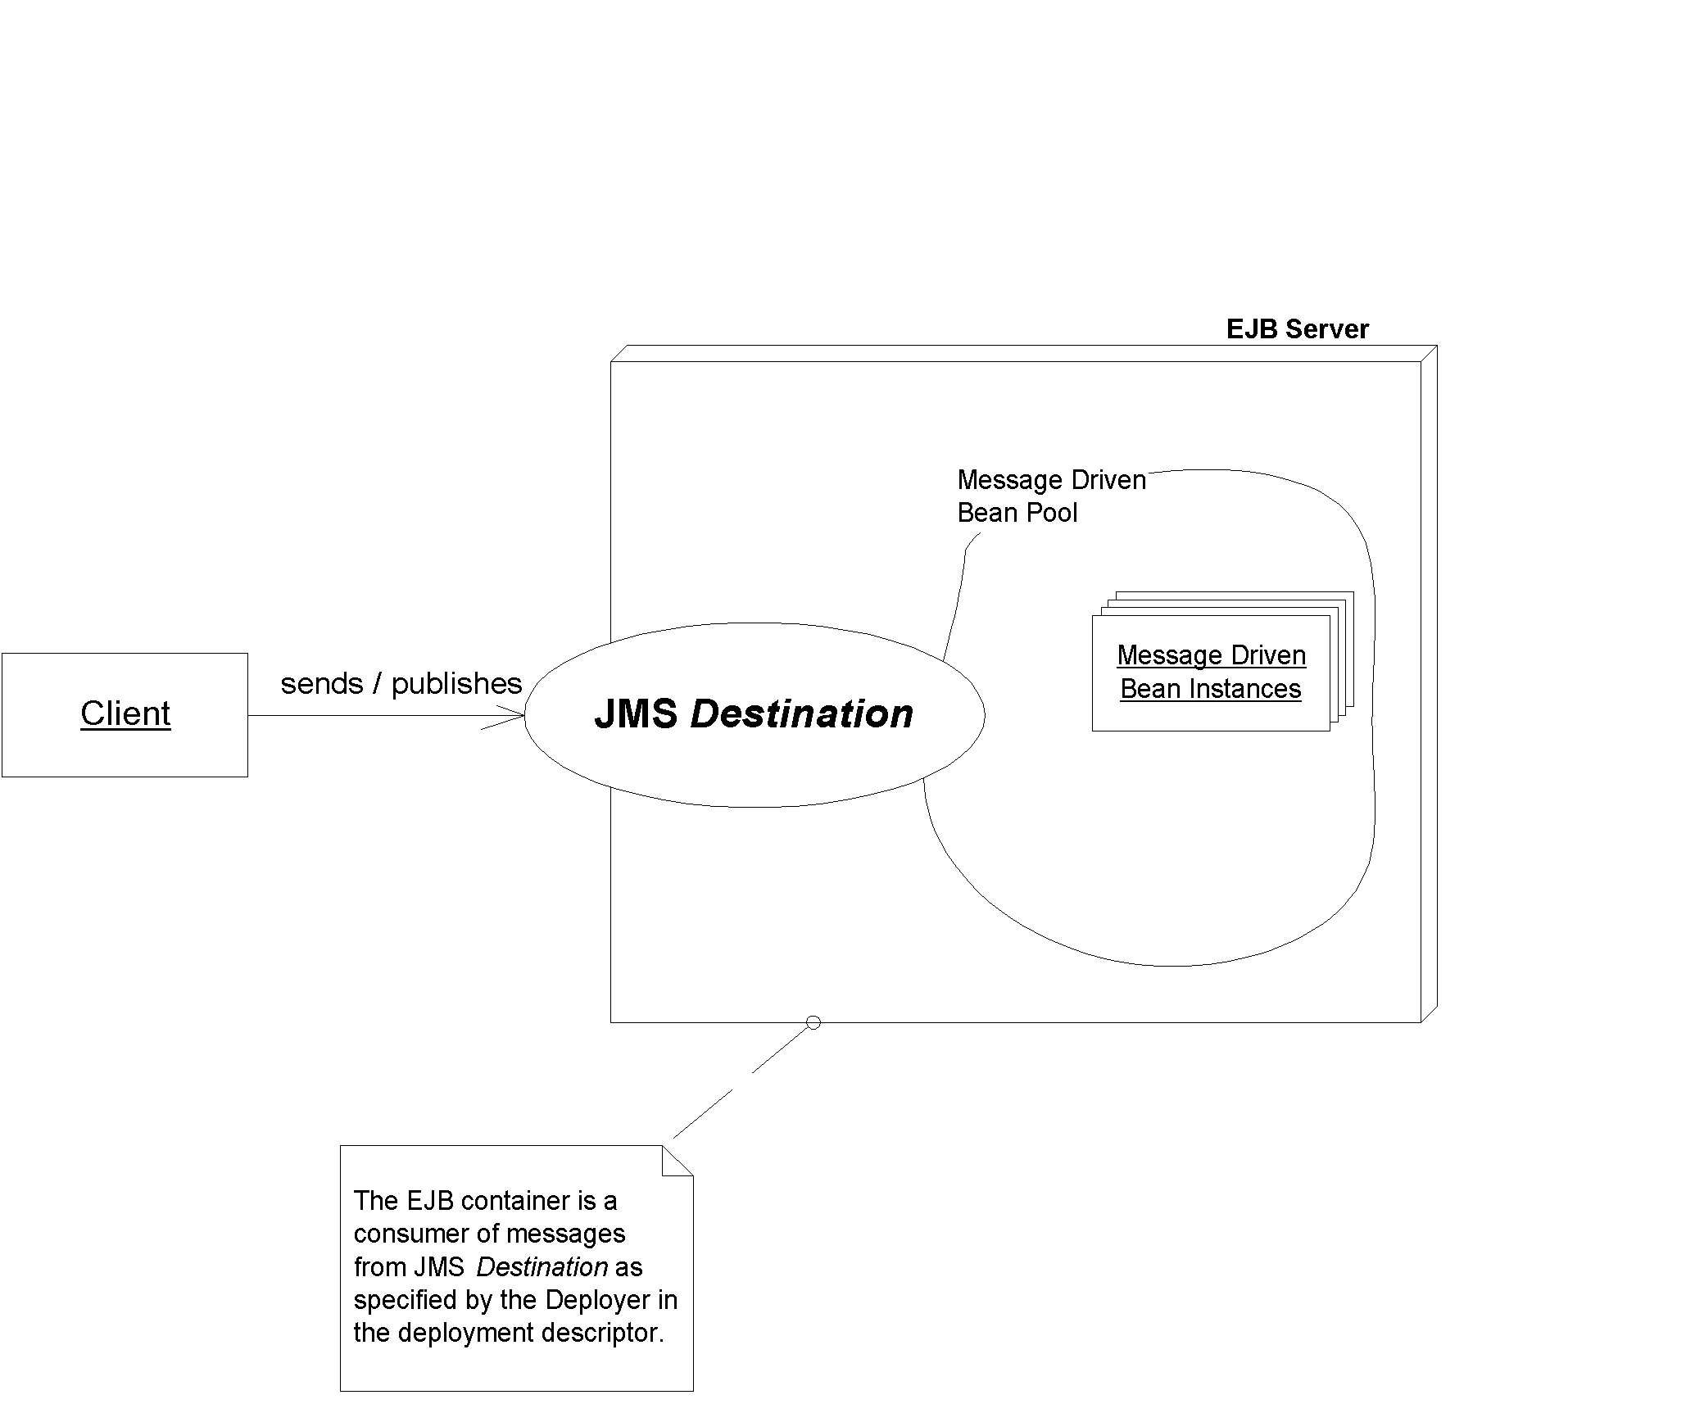
Figure 8.4 A client calling message-driven beans.
The following are some major characteristics of message-driven beans:
A message-driven bean does not have a home interface, local home interface, remote interface, nor a local interface. You do not call message-driven beans using an object-oriented remote method invocation interface. The reason is because message-driven beans process messages, and those messages could come from any messaging client, such as an MQSeries client, an MSMQ client, or (most likely) a J2EE client using the JMS API. Message-driven beans can consume any valid JMS message, from either a topic or a queue.
Message-driven beans have a single, weakly-typed business method. Message-driven beans are merely receiving messages from a JMS destination, and that JMS destination doesn't know anything about what's inside the messages. Therefore, a message-driven bean has only one business method, called onMessage(). This method accepts a JMS Message, which could represent anything--a BytesMessage, ObjectMessage, TextMessage, StreamMessage, or MapMessage. You can't provide lots of different business methods on your message-driven beans; rather, you need to crack open the message at runtime and figure out what to do with it, perhaps with a bunch of 'if' statements. A formal way to say this is, you don't get compile-time type-checking of messages that are consumed. Rather, you need to use the instanceof operator to determine the exact type of a consumed message at runtime. This also means you need to be really careful and make sure that the message you receive is intended for you. By way of comparison, session or entity beans can support lots of strongly typed business methods. Type checking can be performed at compile time to ensure that clients are properly using a given interface.
Message-driven beans do not have any return values. This is because message-driven beans are decoupled from message producers. The message producers don't wait for your message-driven bean to respond, because they continue processing once the message is sent. The good news is that it is possible to send a response to a message producer using any number of design patterns. We discuss this later in this chapter.
Message-driven beans cannot send exceptions back to clients. Again, this is because message producers don't wait for your message-driven bean to receive a message, so therefore they can't receive any exceptions. In fact, the EJB specification goes so far as to prohibit application exceptions from being thrown by a message-driven bean. A message-driven bean, however, is allowed to generate system exceptions. The container (rather than the client) handles system exceptions.
Message-driven beans are stateless. Message-driven beans hold no conversational state. This is because it would be impossible to spread messages across a cluster of message-driven beans if a message-driven bean held state. In this sense, they are similar to stateless session beans, because the container can similar treat each message-driven bean instance as equivalent to all other instances. All instances are anonymous and do not have an identity that is visible to a client. Thus, multiple instances of the bean can process multiple messages from a JMS destination concurrently.
Message-driven beans can be durable or non-durable subscribers. A durable subscription to a topic means that a JMS subscriber receives all messages, even if the subscriber is inactive. If a message is sent to a topic that has an inactive durable subscriber, the message will be persisted and delivered when the durable subscriber is once again active. A non-durable subscription to a topic means the subscriber only receives messages that are published while the subscriber is active. Any messages delivered while the subscriber is inactive will be lost. Since message-driven bean containers are JMS consumers, the container can register itself as a durable or non-durable subscriber to messages published to a topic. Durability allows persistent messages to be sent to a topic even though the application server hosting the message-driven bean consumers has crashed. The messages will persist until the crashed application server restarts and the durable subscriber message-driven bean container positively acknowledges consumption all of the stored messages.
Developing Message-Driven Beans
Let’s now take a look at what’s involved with developing message-driven beans.
The Semantics
Message-driven beans are classes that implement two interfaces: javax.jms.MessageListener and javax.ejb.MessageDrivenBean. Additionally, every message-driven bean implementation class must provide an ejbCreate() method that returns void and accepts no arguments. Here is what the javax.jms.MessageListener interface looks like:

public interface javax.jms.MessageListener {
public void onMessage(Message message);
}

Here is what the javax.ejb.MessageDrivenBean interface looks like:

public interface javax.ejb.MessageDrivenBean
extends EnterpriseBean {

public void ejbRemove()
throws EJBException;

public void setMessageDrivenContext(MessageDrivenContext ctx)
throws EJBException;
}
We summarize the methods that must be provided in every message-driven bean implementation class in Table 8.1.
Table 8.1 Methods to be implemented in message-driven beans
Method | Description
onMessage(Message) | This method is invoked for each message that is consumed by the bean. The input parameter of the method is the incoming message that is being consumed. The container is responsible for serializing messages to a single message-driven bean. A single message-driven bean can only process one message at a time. It is the container’s responsibility to provide concurrent message consumption by pooling multiple message-driven bean instances. A single instance cannot concurrently process messages, but a container can. This method does not have to be coded for reentrancy and should not have any thread synchronization code contained within.
ejbCreate() | This method is invoked when a message-driven bean is first created and added to a pool. Application server vendors can implement an arbitrary algorithm that decides when to add message-driven bean instances from the pool. Beans are typically added to the pool when the component is first deployed or when message throughput increases. Bean developers should initialize variables and references to resources needed by the bean such as other EJBs or database connections. Bean developers should only initialize references to resources that are needed for every message that is consumed by the bean. This is opposed to gaining access and releasing the resource every time a message is consumed.
ejbRemove() | This method is invoked when a message-driven bean is being removed from a pool. Application server vendors can implement an arbitrary algorithm that decides when to remove message-driven bean instances from the pool. Beans are typically removed from the pool when the component is being undeployed or when message throughput decreases and idle instances are wasting system resources. Bean developers should use this method to clean up any dangling resources that are used by the bean.
setMessageDrivenContext(MessageDrivenContext) | This method is called as part of the event transition that a message-driven bean goes through when it is being added to a pool. This method is called before the ejbCreate() method is invoked. The input parameter for this method is an instance of the MessageDrivenContext interface. The input parameter gives the bean access to information about the environment that it executes within. The only methods on the MessageDrivenContext that are accessible by the message-driven bean are transacted-related methods. Other methods, such as getCallerPrincipal(), cannot be invoked in this method because message-driven beans do not have home or remote interfaces and no client-visible security context.
Given this simple description listed here, you can see that developing message-driven beans is significantly less complicated than developing session or entity beans. The number of methods that have to be implemented is less than session or entity beans
The life cycle of a message-driven bean is also very straightforward. See Figure 8.5 for a diagram of the lifecycle of a message-driven bean. A message-driven bean is either in the “Does Not Exist” state or in the “Pooled” state. When a container decides to add another instance to its pool, it will create a new instance, pass the instance its MessageDrivenContext object describing the domain, and then call ejbCreate() allowing the bean to initialize itself. It is likely that application server will create an initial pool of beans at boot time and then increase the size of the pool as the quantity of messages increases. A container will remove an instance from the pool and destroy it at system shutdown or when the container decides it needs to decrease the size of the pool to conserve cache space. If the container decides to take an instance out of the bean pool, it will call the bean’s ejbRemove() method.
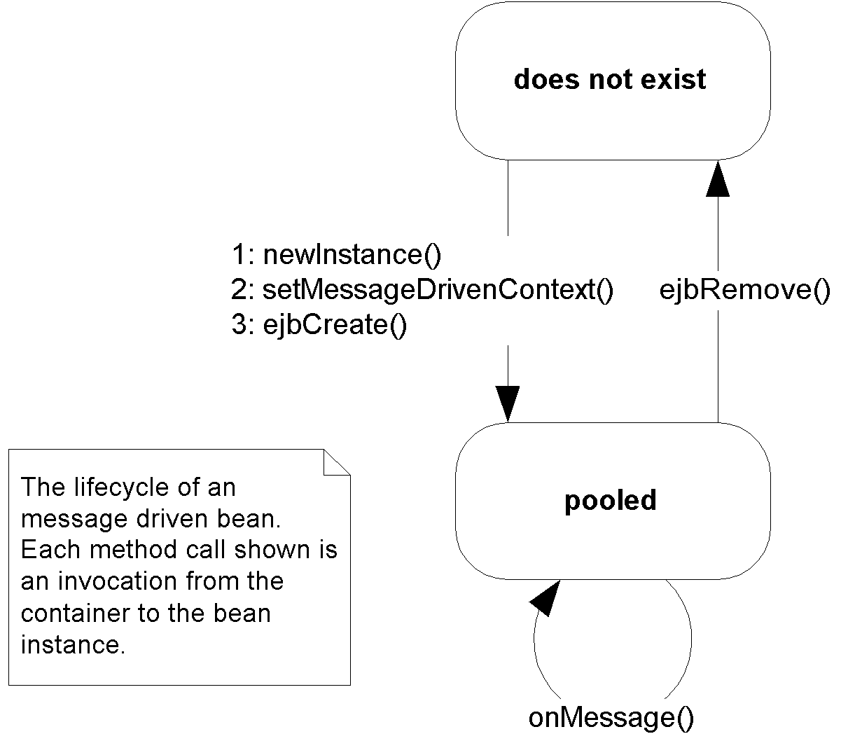
Figure 8.5 Lifecycle of a message-driven bean.
A Simple Example
Now that we’ve learned the theory behind message-driven beans, let’s apply our knowledge and construct a simple bean that logs text messages to the screen. In the future, you could generalize this bean and make it into a generic logging facility, where you have different log levels depending on the urgency of the log.
This is a trivial example, and is not demonstrative of real-world systems. It is, however, a good template for you to use when writing your own beans. If you want to see a real-world message-driven bean in action that uses other EJB components, see Chapter 17, along with the book's accompanying source-code.
As we will see when writing this bean, the rules for writing message-driven beans are trivial. Part of the reason behind this is that message-driven beans are brand-new to the EJB 2.0 specification. As the technology matures, we're sure that Sun will come up with a bunch of special rules and restrictions for message-driven beans. For now, we get to bask in the simplicity.
The Bean Implementation Class
Since message-driven beans do not have home, component, local home, or local interfaces associated with them, we can completely skip designing the public interface to our bean. Rather, we can get right to the heart of development of this bean and write the implementation class. The code for the implementation class is shown in Source 8.2.
package examples;

import javax.ejb.*;
import javax.jms.*;

/**
* Sample Message-Driven Bean
*/
public class LogBean implements MessageDrivenBean, MessageListener {

protected MessageDrivenContext ctx;

/**
* Associates this Bean instance with a particular context.
*/
public void setMessageDrivenContext(MessageDrivenContext ctx) {
this.ctx = ctx;
}

/**
* Initializes the bean
*/
public void ejbCreate() {
System.err.println("ejbCreate()");
}

/**
* Our one business method
*/
public void onMessage(Message msg) {

TextMessage tm = (TextMessage) msg;

try {
String text = tm.getText();
System.err.println("Received new message : " + text);
}
catch(JMSException e) {
e.printStackTrace();
}
}

/**
* Destroys the bean
*/
public void ejbRemove() {
System.err.println("ejbRemove()");
}
}
Source 8.2 LogBean.java.
This is about the most basic message-driven bean that you can have. Notice the following:
- Our bean implements the javax.ejb.MessageDrivenBean interface that makes it a message-driven bean.
- Our bean implements the javax.jms.MessageListener interface that provides the methods necessary for message consumption.
- The setMessageDrivenContext(…) method associates a bean with an environment. We store the context as a member of the implementation class so that other methods of the bean can make use of it.
- The bean is stateless and does not contain any client-specific state that spans messages. Therefore, each bean is identical and has an identical initialization method--a simple ejbCreate() that takes no arguments.
- The onMessage(…) method receives a message, and checks to make sure that the passed-in message is of type TextMessage by using the instanceof operator and then downcasts appropriately. If the passed in message is not a TextMessage, the method just returns. TextMessage is a particular type of JMS message that has methods for getting and setting the text as the body of the message. After downcasting the input parameter, the method prints out the content of the message, if any exists.
- When the bean is being destroyed, there is nothing to clean up, so we have a very simple ejbRemove() method.
Notice also that you don't hard-code message-driven beans for specific a queue or a topic. Your message-driven bean code is independent of destination. The deployment descriptor determines whether a topic or a queue is consumed, as we will see.
The Deployment Descriptor
Message-driven beans only have a couple of deployment descriptor tags that are applicable to them. The portion of the deployment descriptor that is relevant to our simple message-driven bean is shown in Source 8.3.
<!DOCTYPE ejb-jar PUBLIC "-//Sun Microsystems, Inc.//DTD Enterprise JavaBeans 2.0//EN" "http://java.sun.com/j2ee/dtds/ejb-jar_2_0.dtd">

<ejb-jar>
<enterprise-beans>

<!--
For each message-driven bean that is located in an
ejb-jar file, you have to define a <message-driven> entry
in the deployment descriptor.
-->
<message-driven>

<!-- The nickname for the bean could be used later in DD -->
<ejb-name>Log</ejb-name>

<!-- The fully qualified package name of the bean class -->
<ejb-class>examples.LogBean</ejb-class>

<!-- The type of transaction supported (see Chapter 10) -->
<transaction-type>Container</transaction-type>

<!-- Whether I'm listening to a topic or a queue -->
<message-driven-destination>
<destination-type>javax.jms.Topic</destination-type>
</message-driven-destination>
</message-driven>
</enterprise-beans>
</ejb-jar>
Source 8.3 ejb-jar.xml for the simple bean.
Table 8.2 contains definitions for additional deployment descriptor tags that are unique to message-driven beans. All of these tags are optional. Just glance over it now--it's not important to fully understand them if you're just starting to learn message-driven beans. See Appendix C for a complete deployment descriptor reference.
Table 8.2 Optional sub-elements for the <message-driven> tag
Method | Description | Example
<message-selector> | A message selector filters, or limits, which messages are sent to your bean. Only messages whose headers match the selector are delivered. Message selectors increase overall performance by reducing the number of messages that are delivered to clients that have no interest in the message. See the JMS specification, downloadable from http://java.sun.com, for the complete rules for message selector syntax. | <message-selector>  JMSType = 'log' AND  logLevel = 'severe'  </message-selector>
<acknowledge-mode> | If you let the container handle transactions for you (called container-managed transactions described in Chapter 10) then the container delivers the message to you in a transaction. There is no need for message acknowledgement then, because if the transaction rolls back, then the message will automatically be put back on the queue. If you program your own transactions (called bean-managed transactions) then the transaction occurs within your bean, and begins and ends after the message has been delivered to your bean, and thus the consumption of the message occurs outside the transaction. Therefore, if you're using bean-managed transactions, then you need to tell the container to acknowledge messages. Setting this tag to Auto-acknowledge will force the container to acknowledge a message when the message-driven bean’s onMessage() method has successfully returned. Setting this tag to Dups-ok-acknowledge allows the container to acknowledge the message when it feels like doing so, to save resources and processing time. Since it may not acknowledge the message fast enough, you run the risk of the JMS destination sending you a duplicate message. You should only use this if you can tolerate duplicate messages. | <acknowledge-mode>  Auto-acknowledge  </acknowledge-mode>
<message-driven-destination>  <destination-type>  <subscription-durability>  </message-driven-destination> | This tag is optional. This tag provides advice to the Deployer as to whether a message-driven bean is intended for consumption by a queue or a topic. The Bean Developer is responsible for providing initial values to these tags even though the Bean Deployer may override them. This element has two sub-elements: <destination-type> and <subscription-durability>. The valid values for <destination-type> are javax.jms.Queue and javax.jms.Topic. If the <destination-type> tag is javax.jms.Topic, the <subscription-durability> element may be included to indicate whether or not this message-driven bean should be a durable topic subscriber of messages. The valid values for <subscription-durability> are durable and nondurable.
As you can see, developing the deployment descriptor for message-driven beans is very simple. In addition to the characteristics that are definable for all message-driven beans, application server vendors can provide value-add extensions in an application server-specific deployment descriptor. For example, an application server vendor may provide a deployment descriptor parameter that defines the maximum size of the message-driven bean pool and/or another parameter that defines its initial size.
A question that you should be asking right now is “exactly how does the application server bind a message-driven bean container to a specific topic or queue?” If you look carefully at the deployment descriptor provided in Source 8.3, the <message-driven-destination> tag specifies whether the bean should consume queue or topic messages, but it never indicates which topic or queue the message-driven bean container should bind to. This is done purposefully to make message-driven beans portable across application servers. Since the names of actual topics and queues deployed into a JMS server are application server-specific, the mapping of a bean’s container to a specific JMS server destination has to be done in an application server-specific deployment descriptor. It is expected that most EJB vendors will have a custom deployment descriptor that binds the bean to a specific destination.
The Client Program
The client application for our simple message-driven bean example is the JMS client we developed earlier in this chapter in Source 8.1. This shows you the power of message-driven beans--our client is solely a JMS client and the application is never the wiser that a message-driven bean is consuming the messages.
If you'd like to try this example out yourself, see the book's accompanying source code for compilation and deployment scripts.
Advanced Concepts
Now that we have discussed the mechanics involved with developing message-driven beans, let’s take a deeper look at the support containers can give for message-driven beans and how they might integrate with transactions, advanced JMS features, and behave in a clustered environment.
Transactions
Message-driven beans do not run in the same transaction as the producer who sends the message. This is because there are typically two transactions associated with every durable JMS message (one transaction for the producer to put the message on the queue, and another transaction for the message-driven bean to get the message off the queue). It is theoretically impossible for the message-driven bean to participate in the same transaction (and hence the same unit of work) as the producer, because until the producer commits his transaction, the message wouldn't even appear on the queue!
For a complete discussion of transactions and how they apply to message-driven beans, see Chapter 10.
Security
Message-driven beans do not receive the security identity of the producer who sends the message. This is because there is no standard way to stick security information into a JMS message. Therefore, you can't perform EJB security operations (described in Chapter 9) with message-driven beans.
Load-balancing
Clustering message-driven beans is quite different than clustering session or entity beans (see Chapter 14). With session and entity beans, your requests are load-balanced across a group of containers. The load-balancing algorithm makes a guess about which server is the least-burdened server, and pushes requests out to that server. It's guessing because the client's RMI-IIOP runtime can never know for sure which server is the least burdened, because all load-balancing algorithms are approximation algorithms based on imperfect data. This is called a push model because we are pushing requests out to the server, and the server has no say in the matter about what requests it receives.
With message-driven beans, producers put messages onto a destination. The messages will reside in the destination until a consumer takes the messages off of the destination, or (if the messages are non-durable) the server hosting the destination crashes. This is a pull model since the message will just reside on the destination until a consumer asks for it. The containers contend (fight) to get the next available message on the destination.
Thus, message-driven beans feature an ideal load-balancing paradigm and is much more smooth for distributing load than session or entity beans. The server that is the least burdened and asks for a message gets the message. The tradeoff for this optimal load-balancing is that messaging has extra overhead because there's a destination "middleman" sitting between the client and the server.
Duplicate Consumption in a Cluster
Since JMS topics use the publish/subscribe model, it’s possible that a message sent to a JMS topic will be delivered to more than one consumer. Since many containers will create a pool of many message-driven beans instances to concurrently process multiple messages, some concern can arise around message-driven bean containers that subscribe to JMS topics.
In particular, if a message-driven bean container has pooled five instances of its message-driven bean type and is subscribed to the DogTopic, how many consumers will consume a message sent to the DogTopic topic? Will the message be consumed by each message-driven bean instance in the container or just once by a single message-driven bean? The answer is simple: a container that subscribes to a topic will only consume any given message once. This means that for the five instances that the container created to concurrently process messages, only one of the instances will receive any particular message freeing up the other instances to process other messages that have been sent to the DogTopic.
Be careful, though. Each container that binds to a particular topic will consume a message sent to that topic. The JMS subsystem will treat each message-driven bean container as a separate subscriber to the message. This means that if the same message-driven bean is deployed to many containers in a cluster, then each deployment of the message-driven bean will consume a message from the topic it subscribes to. If this is not the behavior you want, and you need exactly once consumption of a message, then you should consider deploying a queue instead of a topic.
For message-driven beans that bind to a queue, the JMS server will only deliver any message on the queue to one consumer. Each container will register as a consumer to the queue and the JMS server will load balance messages to consumers based upon availability. Message-driven beans that bind to queues that are deployed in a cluster are ideal for scalable processing of messages. For example, if you have two servers in your cluster and 50 messages on a queue, each server will consume on average 25 messages. This would be opposed to a single server responsible for consuming 50 messages.
Message-driven beans in a cluster are shown in Figure 8.6. Notice that many message-driven beans process the same message from Topic #1. Also notice that only a single bean processes any given message from Queue #1.
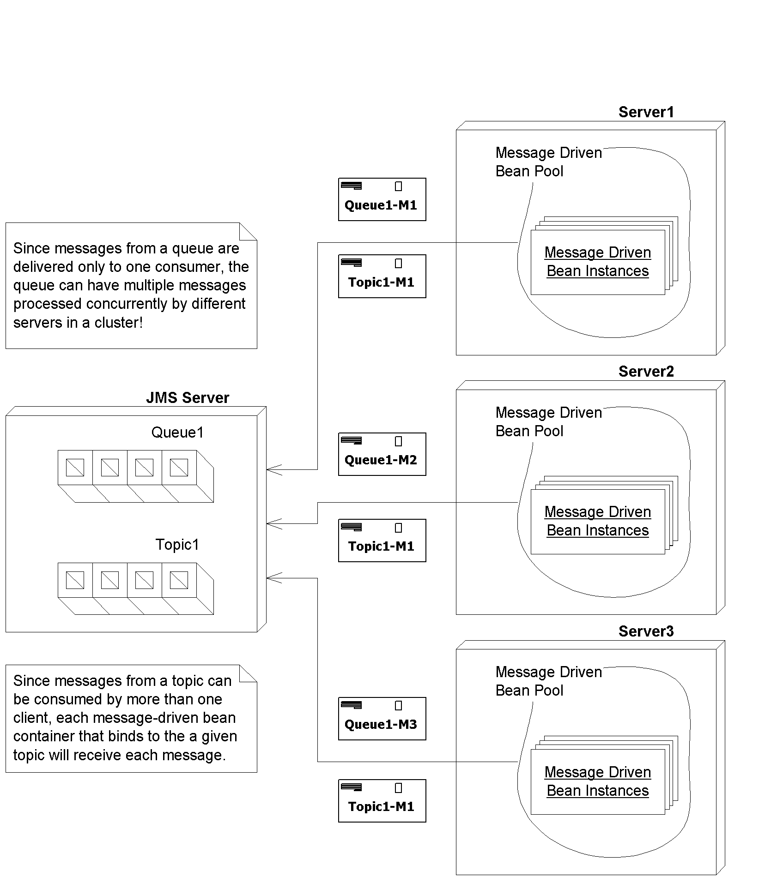
Figure 8.6 Message-driven beans in a cluster.
Using queues to partition business processing in a cluster
Suppose you have two clusters of machines: one cluster is configured for a development and test environment and the other cluster is configured for a production environment. You need to make sure that traffic coming from test clients are sent to the development cluster, while traffic coming from real clients are sent to the production cluster.
As one solution, you could setup your JMS server with two queues: DevelopmentQueue and ProductionQueue. You could then deploy a series of JSPs or front-end stateless session beans that analyze each incoming request, formats it into a JMS message, and then places requests onto one of the queues. Requests that come from an internal development machine could be placed onto the DevelopmentQueue and all other requests could be placed on the ProductionQueue.
On the back end, you could configure two clusters: one cluster has message-driven beans bound to the DevelopmentQueue and the other cluster has message-driven beans bound to the ProductionQueue. The logic for each of these beans can vary based upon the needs of the system. For example, the behavior of the message-driven beans bound to the DevelopmentQueue can mimic those bound to the ProductionQueue but additionally add on additional debugging statements. Also, you can tune each cluster independently based upon load to the system. Since the ProductionQueue will likely have more throughput than the DevelopmentQueue, you could independently grow the size of the cluster servicing the ProductionQueue without impacting the cluster servicing the DevelopmentQueue.
This illustrates a general paradigm of using queues to partition business logic processing. Rather than the servers pulling messages off a single queue, you are pre-choosing which machines get the messages by splitting the queue into two queues. This is an artificial way to achieve control load-balancing in a JMS system.
Message-Driven Bean Gotchas
Even though developing message-driven beans are a straightforward process, there are many dark corners and caveats that can be encountered unknowingly. In this section we hope to uncover some of these message-driven demons and even offer some suggested solutions to help speed you on your way to successful implementation.
Message Ordering
A JMS server is not guaranteed to deliver messages to a pool of message-driven beans in any given particular order. The container will likely attempt to deliver messages in an order that doesn’t impact the concurrency of message processing, but there is not guarantee as to the order the beans actually process the message. Therefore, message-driven beans should be prepared to process messages that are not in sequence. For example, a message adding a second hamburger to a fast food order might be processed before the message indicating that a new fast food order with a hamburger should be created. Bean developers will have to take these scenarios into account and handle them appropriately.
Missed ejbRemove() Calls
As with session and entity beans, you are not guaranteed that the container will call your ejbRemove() method when your bean is destroyed. In particular, if there is a system crash or if there is a crash from within the EJB container, any active message-driven bean instances will be destroyed without going through the proper lifecycle shutdown. Additionally, for any method that throws a system exception, such as EJBException, the ejbRemove() method will not be invoked. Developers should be alert to this fact and perform any relevant cleanup before throwing a system exception.
Developers should also be aware that the ejbRemove() method is only invoked by the container when the container no longer needs that instance. Many containers will pool the necessary number of message-driven bean instances needed to concurrently handle multiple messages. The boundaries on the minimum and maximum size of the message-driven bean pool will typically be set in an application-server specific deployment descriptor. A container will add and remove message-driven bean instances to and from the pool as appropriate. However, since message-driven beans are extremely lightweight objects, a container will generally destroy a message-driven bean instance only when the EJB itself is being undeployed (i.e., the whole EJB component is being undeployed). And, for most systems, the only time container undeployment occurs is at system shutdown or when an administrator decides to undeploy the component. The important point here is that message-driven bean containers are rarely undeployed and, therefore, message-driven instances will rarely be destroyed. So, as a general rule of thumb, the ejbRemove() method will rarely be invoked.
Poison Messages
When using container-managed transactions (see Chapter 10) with a message-driven bean, it’s easy to code yourself into a situation that causes the generation of poison messages. A poison message is a message that is continually retransmitted by a JMS destination to consumer because the consumer continuously fails to acknowledge the consumption of the message. Any time your message-driven bean does not acknowledge messages to the JMS destination, you potentially enter into a situation where poison messages can be created. See Figure 8.7 to see a diagram indicating how poison messages can inadvertently be generated.
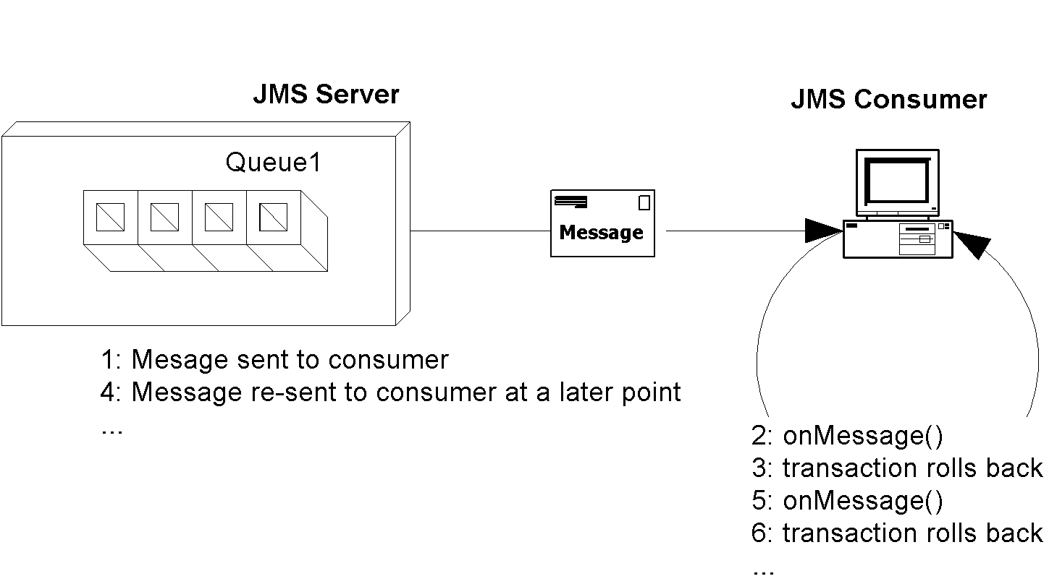
Figure 8.7 How message-driven beans can cause poison messages
As an example, suppose you have a stock-quoting message-driven bean that accepts a text message, which represents the stock ticker symbol to be quoted. Your bean cracks open that message. If the string contained within the message matches a stock symbol, the bean retrieves the value of that symbol and sends a response message. Otherwise, the bean throws a system exception or calls MessageDrivenContext.setRollbackOnly(). This causes the transaction to be rolled back, which means the message acknowledgement never to be sent to the JMS destination. The JMS destination will eventually resend the same message to the container causing this same process to occur.
See Source 8.4 for an example of a message-driven bean implementation class that will cause a poison message scenario.
package examples;

import javax.ejb.*;
import javax.jms.*;

public class PoisonBean
implements MessageDrivenBean, MessageListener {

private MessageDrivenContext ctx;

public void setMessageDrivenContext(MessageDrivenContext ctx) {
this.ctx = ctx;
}

public void ejbCreate() {}

public void ejbRemove() {}

public void onMessage(Message msg) {
try {
System.out.println("Received msg " + msg.getJMSMessageID());

// Let's sleep a little bit so that we don't
// see rapid fire re-sends of the message.
Thread.sleep(3000);

// We could either throw a system exception here or
// manually force a rollback of the transaction.
ctx.setRollbackOnly();
}
catch (Exception e) {
e.printStackTrace();
}
}
}
Source 8.4 PoisonBean.java.
There are a several strategies you can use to resolve poison messages:
- Make sure to not throw any system exceptions for any business-logic related error conditions. System exceptions such as EJBException are intended to indicate system and/or container failure. If this were a session or entity bean, the ideal solution would be to generate an application exception and throw it (especially since application exceptions do not force transactions to be rolled back). However, the EJB specification prohibits application exceptions from being thrown from the onMessage() method of a message-driven bean. The ideal solution to this problem would likely involve logging the business error message and then quietly returning.
- Consider using bean-managed transactions instead of container-managed transactions. Message consumption and acknowledgement will not be part of the transaction if bean-managed transactions are used. A bean-managed transaction can be rolled back and the message will be acknowledged anyway.
- Some application servers allow you to configure a poison message queue. Messages that are redelivered a certain number of times will be flagged as poison messages and removed from their primary queue and placed into a poison message queue. Typically, any message that is redelivered 3-5 times can be considered a poison message. You can then bind special consumers or message-driven beans to the poison message queue to handle any unexpected error conditions.
- Some application servers will place a retry count value as a property of any redelivered messages. Each re-delivery of a message will increment the retry count. Your message-driven bean could check the value of a retry count (if it exists) to see if it has repeatedly consumed the same message.
- Some application server vendors provide a redelivery delay feature that administrators can configure to determine how long the JMS destination will delay the redelivery of a message after it receives a negative acknowledgement. This way, your system doesn't grind to a halt in case of rapid-fire poison messages.
How to return results back to message producers
The EJB specification does not outline any mechanism that allows a message-driven bean to propagate a response back to the client that originally generated the message. So we need to build those facilities ourselves. Figure 8.8 shows how this could be accomplished.
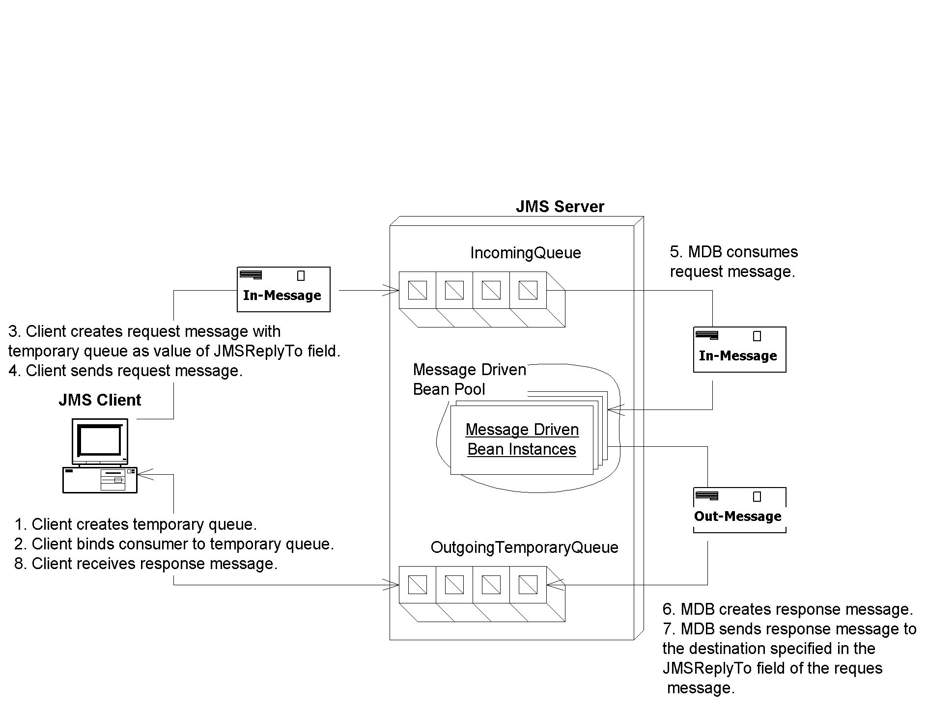
Figure 8.8 A simple request/response paradigm solution
Here is an explanation of Figure 8.8:
- The client that generates a JMS message for consumption creates a temporary destination associated with its Connection. The JMS server will temporarily create a Topic or Queue and that object will exist for the lifetime of the Connection.
- The request message that the client sends contains extra information, so that the receiving message-driven bean knows how to reply correctly. Specifically, the client sticks the name of the temporary queue in the JMSReplyTo header field of the request message. The message-driven bean can harness this field to reply on the correct queue. The client also has a unique identifier of the original message in the JMSCorrelationID header field of the original message. When the message-driven bean replies, the message-driven bean embeds this original identifier, so the client knows to which original message he's receiving a reply
- The client creates a new Session and registers a MessageListener to consume messages sent to the temporary destination that was just created.
- The client sends the message.
- After consuming the message, the message-driven bean formats a response and sends it using the JMSReplyTo and JMSCorrelationID attribute of the received message.
- The client's MessageListener class asynchronously consumes the message that is sent to the temporary destination, recognizes that it is a response to the original message, and processes it.
Even though this scenario seems like a straightforward solution for responding to clients from within a message-driven bean, it could potentially lead to some unexpected results. The problem arises if the client itself is an EJB component, such as a stateful session bean. When your stateful session bean creates the temporary destination, that temporary destination has a lifespan equal to the lifespan of the JMS connection that your bean currently holds. If your bean is passivated (meaning swapped out of memory) then you need to release that connection. The temporary destination then goes away, and you've lost all messages that have been delivered to that temporary destination while you were passivated, even if you re-create the destination after you are swapped into memory again.
We propose two possible solutions to this problem:
- Don't use a stateful session bean. Rather, the end client, such as a servlet, application, or JSP tag library (rather than the stateful session bean) creates a temporary queue that all response messages are sent to. The stateful session bean is therefore not holding onto a connection, and so there is no danger of the destination going away because of passivation. See the book's accompanying source code for an implementation of this solution.
The advantages of using this architecture include:@@@COMP: UL within NL@@@
Ease of implementation. Creating temporary queues doesn’t require any extra configuration from an administrator, whereas setting up a dedicated response topic that requires management on the part of the administrator and your application (see other implementation following).
Security. Since temporary queues are bound to a particular connection, it is not possible for malicious clients to bind to a temporary queue and intercept response messages.
Immediate client notification. Since the remote client creates and manages the receiving logic for the temporary queue, the client will immediately be notified when a response message is generated, rather than having to wait for a middleman session bean to respond.
The disadvantages of this architecture include:@@@COMP: UL within NL@@@
No persistent messages. Temporary queues cannot have persistent stores associated with them and therefore cannot support guaranteed message delivery. If the system fails while a response message is located on the temporary queue, it will be lost.
Poor abstraction. Since temporary queues are associated with a Connection object, it is not possible to have a stateful session EJB perform middle-tier management of the request/response process. It might be more natural to abstract away the JMS request/response logic from the client.
- A permanent response topic is configured and deployed in the JMS server. All response messages are delivered to the same response topic for all clients. Clients filter out the messages that belong to them by registering a message selector with the JMS server. Any request message that is sent has a custom application property called ClientName=MyID where MyID varies for each client. The message-driven bean that consumes the request message takes the application property from the request message and inserts the same property in the response message. All response messages are sent to the same response topic irrespective of the client. Figure 8.9 is an illustration of this scenario, and the book's accompanying source code has its implementation.
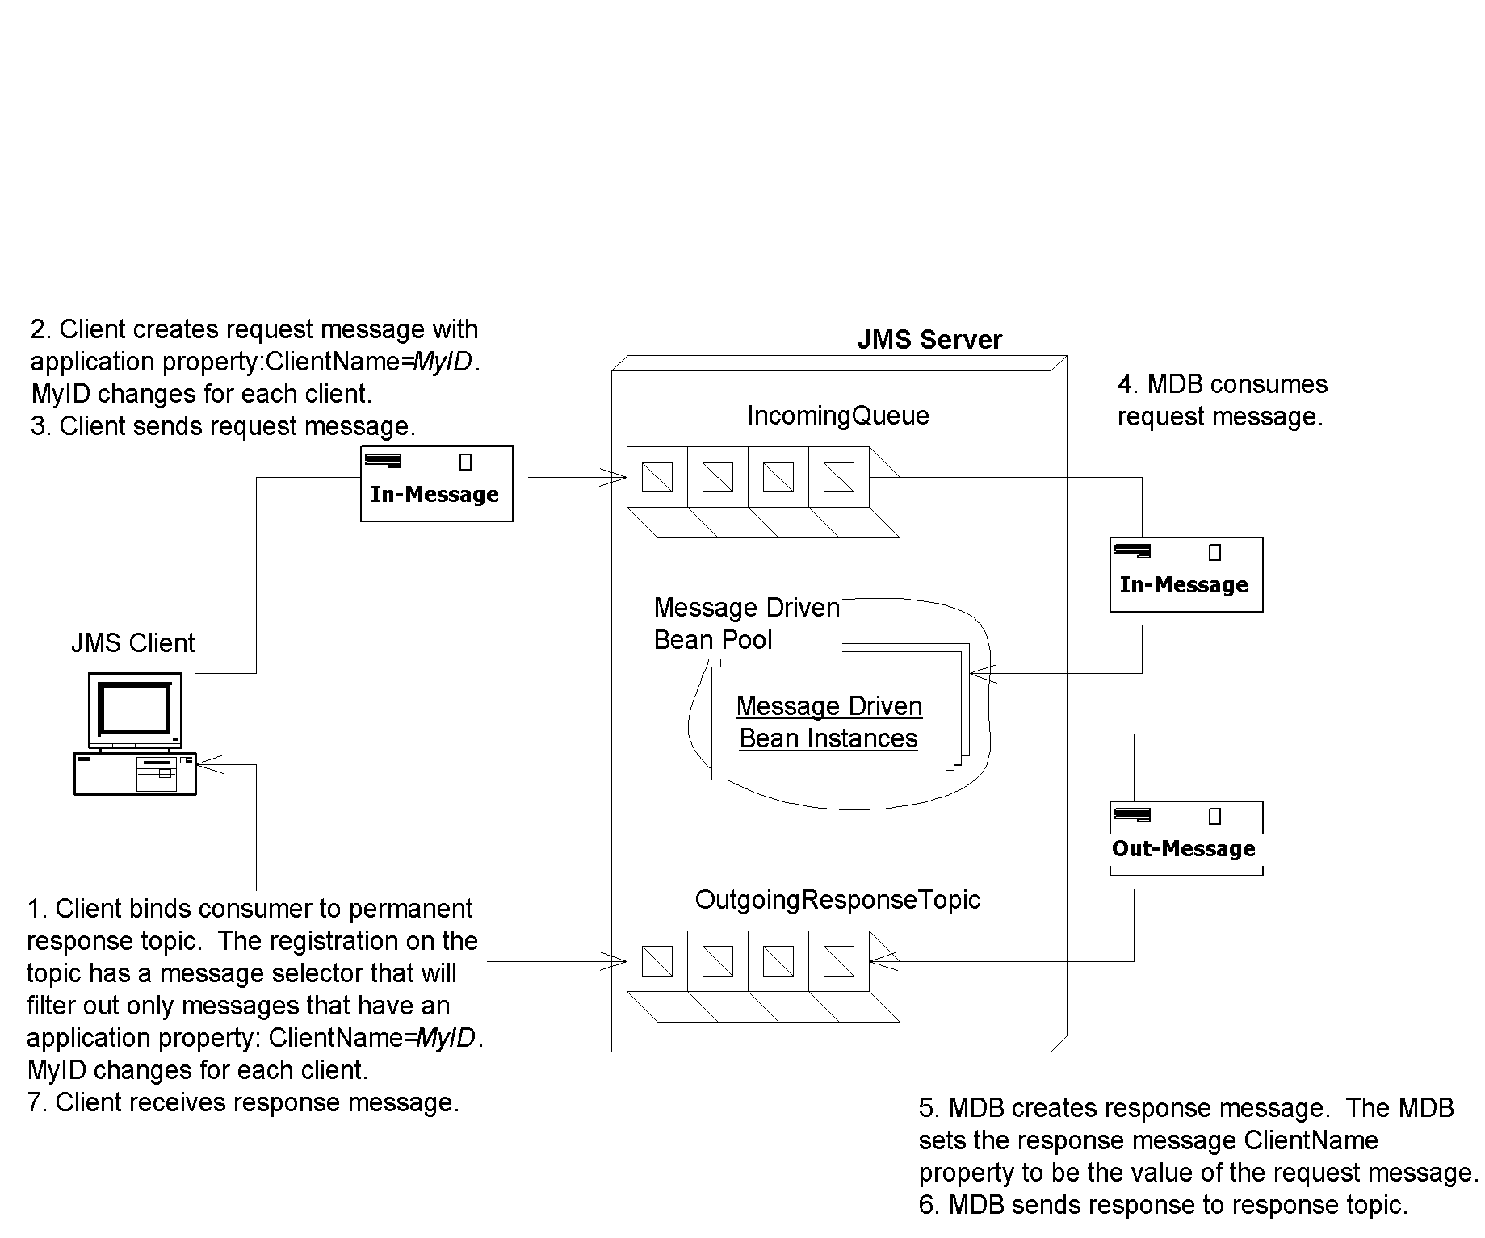
Figure 8.9 Another request/response paradigm solution
The advantages of using this architecture include:@@@COMP: UL within NL@@@
Better fault tolerance. Since this architecture proposes that a permanent topic be set up for all outgoing messages, the response topic could be associated with a persistent store. All outgoing messages could then be sent persistently with guaranteed message delivery. Temporary topics and queues cannot have persistent messages delivered to them. This could be ideal for a data retrieval system. For example, suppose you had a remote client that randomly connected to the central server requesting a download of the latest market data as it pertains to that client. The data could be anywhere from 1K to 1MB. Let’s also suppose that for situations where a large amount of data needs to be retrieved for the client, you want to break up the data chunks into 100K messages. If the client needed to retrieve 1MB of data, you would need to send 10 response messages. All of the response messages could be sent with guaranteed message delivery. If the remote client application were to fail during the download process, it could easily resume from the last response message that it received instead of having to restart the entire download process.
Better filtering. You can add on additional filtering of response messages through the message selector that the client registers with the JMS server. In the example provided with this book, the client just registers to receive messages that have an application property ClientName=MyID. You could conceivably add on additional application properties about the response message that the client filters on. These properties could be message size, message importance, etc.
The main disadvantage of this architecture is security. Since the JMS specification doesn’t have any security restrictions around which clients can bind which message selectors, any client can register any message selector. This opens up the opportunity for a malicious client to register for consumption of response messages that are destined for another client. This malicious behavior is not possible with temporary destinations. Of course, if you're secured by a firewall, security probably doesn't matter. Also, it would take a pretty snazzy developer to actually figure out that you're sending messages and register a message listener.
As a final note, it is important to mention that this approach allows a session EJB to act as a mediator between the client and the back-end system, as mentioned in the actual description of the problem. By using an intermediary session EJB, security can be improved since the topic that response messages are delivered to can be made available only internally by simply not exposing it to a client or blocking the message server using a firewall or other security measure. The session EJB can be coded to filter out messages based upon the logged-in user name.
An alternative request/response paradigm
If you don't feel like writing your own request/response code as we've just described, you can also tap into JMS' facilities to help you. JMS has two special classes, javax.jms.QueueRequestor and javax.jms.TopicRequestor, which implement a simple request/response paradigm. The idea is you call a method called request() that takes as input the request message and returns the response message. This is implemented in the book's accompanying source code.
The downsides to this approach are:
You need to block when waiting for a response. You can't continue processing and do other things, which is one of the major advantages of messaging in the first place.
You can't use transactions. If you did, the outgoing message would be buffered until the transaction committed. Since the QueueRequestor class doesn’t commit right away, but rather blocks until it receives a response message, it will block indefinitely. The outgoing request message will wait forever to be flushed from the buffer. See Chapter 10 for more on transactions.
The Future: Asynchronous Method Invocations
One of the downsides to message-driven beans is that you need to learn a whole new API, JMS, to call them. This API is highly procedural in nature, because you are not invoking lots of different business methods on your message-driven bean--rather, you are sending messages using the JMS API, and the server has a single method to crack the message open and then call the intended method using a giant 'if' statement.
An asynchronous method invocation is a real method invocation executed in an asynchronous fashion. You are actually calling business methods on the server, such as calling logMessage() or quoteStock(). You can choose whether you want to block and wait for an asynchronous response or to immediately return and to not wait for a response. Furthermore, the server can take on the context information of the client.
Asynchronous RMI and Microsoft’s Queued Components are asynchronous method invocation infrastructures. CORBA also has some support for this, with a slightly different definition of deferred synchronous invocations: “A request where the client does not wait for completion of the request, but does intend to accept results later.”
We hope a future EJB specification supports asynchronous method invocations. Until then, you'll have to build such facilities on top of JMS yourself, perhaps by writing a code generator.
Summary
In this chapter, we’ve learned about developing message-driven beans and the pitfalls associated with doing asynchronous development with EJBs. We started by learning about the various benefits of developing asynchronous components and how message-driven beans compare to their session and entity bean counterparts. We then looked at how to build a message-driven bean and deploy it. Next we looked at how a message-driven bean behaves in its environment including how it interacts with transactions. Finally, we took a look at the common pitfalls that can be encountered when using message-driven beans and made some proposals as to their resolution.

